# Sprint 3 Plan - Scrum Tools

## Revision 1 - 2/24/2024

## Sprint Completion - 3/2/2024

# Goal

In this sprint, we want to finish implementing the release plan and all its features, including completing the look, adding all the functionality, and having it be a polished product.

# Spikes/Infrastructure

We must refactor the backend code so that the AppDataSource is placed in a wrapper function for dependency inversion and allow for dependency injection. Then, we must refactor the tests to match the directory structure of the code it tests, as well as writing new tests for the API and having a defined and documented return structure. Also, making minor changes to the entities.

# Task Listing

### Story 1

| **Priority** | **Story** | **Acceptance Criteria** | **SP** |
| --- | --- | --- | --- |
| 1 - Must | As a product owner, I want to create new release plans so I can add to previous plans and communicate my plan to the team. | Have a good form for inputting and editing a release plan  Be able to create a new release plan based on the current release plan  Changes can be saved.  Have automatically generated version numbers depending on if a release plan is created fresh, or if it is a revision of a previous release plan.  Team can see all versions (previous versions, signed versions, unsigned versions) of the release plan. | 5 |

| **Tasks** | **Ideal Hours** |
| --- | --- |
| 1. Update the Backlog to fit the design | 1 |
| 1. Implement the Sanity Check | 3 |
| 1. Implement the Sprints to fit the design (no functionality yet) | 2 |
| 1. Have the project name displayed on the Nav Bar | 2 |
| 1. Allow revision of release plans (create new revision, copy old revision) | 2 |
| 1. Connect the backend functions to the view release plan (revisions, text boxes) | 5 |

# Initial Task Assignment

| Team member | Initial Task |
| --- | --- |
| Edison | Refactoring, then 1.3 |
| Tanya | 1.1, then 1.2 |
| Michael | Investigate Drag and Drop, then 1.4 |
| Arthur | API testing, 1.6 |
| Andrew | Wrapper for DataSource, Refactor tests, then 1.5 |

# Initial Burnup Chart

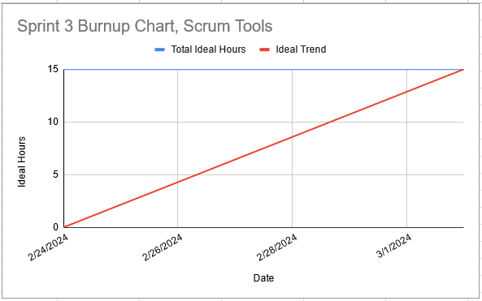

# Initial Scrum Board

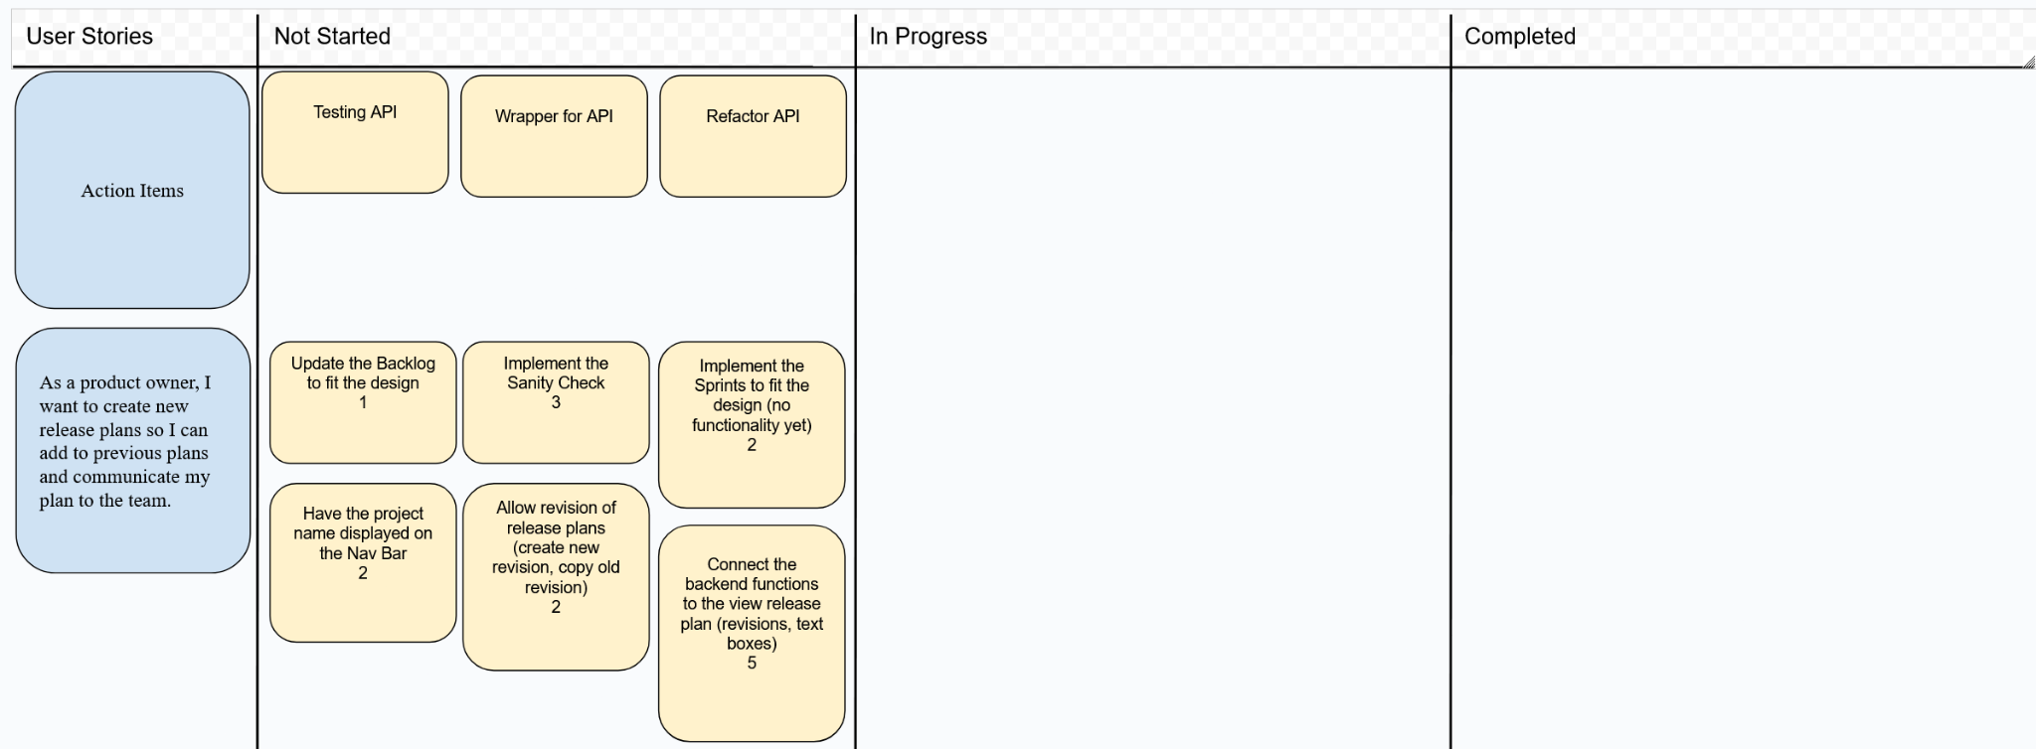

# Team Roles

| **Team member** | **Role(s)** |
| --- | --- |
| Edison | Frontend |
| Tanya | Frontend |
| Michael | Frontend |
| Andrew | Backend/Frontend |
| Arthur | Backend/Frontend |

# Scrum Times

Monday 1:15-2:00 pm (TA meeting)

Wednesday 1:15 pm

Saturday 1:15 pm